**Functional Behavioral Assessment & Behavioral Intervention Plan**

Jennifer Aussicker

School Psychology Program, Rider University

EDPS 591: Internship in School Psychology II

Dr. Stefan Dombrowski

16 March 2025

*Functional Behavioral Assessment*

BACKGROUND INFORMATION

*Reason for Referral*

Hannah was referred by her second grade teacher on 12/14/2023, and an Intervention & Referral Services (I&RS) Committee meeting was held in response to this. Ms. Hayes filled out a Request for Assistance (RFA) form, due to Hannah’s increasing behaviors.

*History*

Hannah is a first grade student in a general education classroom at Old Farmers Road School. Her first grade classroom is composed of 18 students, one General Education teacher, and one classroom aide. Hannah does not receive any related services but does see the school counselor on an as-needed basis. Hannah was tested for Special Education in Preschool due to behavioral concerns at home, as referred by the parents.

Hannah lives at home with her mother, father, and brother, Simon. Hannah has two dogs who she enjoys playing with. Hannah enjoys karate, art, and playing video games. Hannah’s favorite subject in school is Science, and her least favorite subject in school is Language Arts.

Hannah does have some sensory differences and does not enjoy the feeling of restrictive clothing or footwear. For this reason, Hannah will typically come into school in a big tshirt/dress and Crocs, regardless of weather. There have been conflicts having to do with recess and gym attire given her clothing choices. The importance of appropriate clothing for health and safety have been addressed with Hannah, but she refuses to wear any other kind of attire.

Besides sensory differences, Hannah’s main areas of concern are defiance and dishonesty. Oftentimes, Hannah will become defiant when faced with a task that would interrupt a preferred activity or a task that was undesirable to her. Hannah will be dishonest in times where it benefits her, such as if she is asked if she did something wrong, and would get in trouble for it; or if it would take a preferred item away from her (ex. “Hannah, do you have something in your hands right now?” “No.”). Once Hannah displays these behaviors and is confronted about them, she typically will become frustrated, raise her voice, and shut down. Once Hannah is in this state, it is difficult to get her back to calm and ready to learn.

*Assessment Methods:*

* Review of records
* Parent Report (1/30/2024)
* Teacher Interviews (1/30/2024, 1/31/2024)
* Classroom Observations
* Motivation Assessment Scale II
* Data Collection and Analysis, including Antecedent/Behavior/Consequence (ABC) Charts
* Functional Behavior Assessment Teacher Interview Form (1/30/2024)
* Functional Assessment Interview Tool
  + Staff Form (1/30/2024)
  + Parent/Guardian Form (2/2/2024)
* Functional Analysis Screening Tool
* Reinforcement Inventory for Children
* Consultation with the School Nurse, Occupational Therapist, Previous Teacher, and Current Teacher

INTERPRETATION OF FINDINGS

Hannah was assessed using multiple forms of data collection. The observers completed ABC data charts, teacher interviews, and parent interviews in order to gain better understanding of Hannah’s main behaviors of concern.

*Informant Report: Interviews and Rating Scales*

**(Current) Teacher Interview:** Tracy Hayes, 01/30/2024

Ms. Hayes was interviewed by the School Psychologist at Old Farmers Road School on January 30, 2024. This was done via the Functional Behavioral Assessment: Teacher Interview Form, as well as the Functional Assessment Interview Tool: Staff Form.

Academically, Hannah is meeting her goals and expectations. It should be noted that sometimes, Hannah’s behaviors stand in her way academically. When Ms. Hayes is firm with her and tells her that she knows Hannah can do better, it tends to work. Hannah works well in small groups and 1:1 settings in the classroom. In the classroom, Hannah is able to write her name independently, unpack her backpack, hang up her coat, pack up at the end of the day, and enjoys sharing stories with peers and adults. Hannah loves doing arts and crafts (which is a suspected preference which allows for artistic expression). Hannah does attempt her school work, but needs 1:1 assistance to start it and continue working. Hannah often seeks an adult after each step to ask questions.

Behaviorally, Ms. Hayes began by stating that Hannah is “much better” in the morning than in the afternoon, and she tends to escalate in the afternoon. Hannah does not become physically aggressive, but will sometimes elope to escape a non-preferred task that is given to her. Ms. Hayes stated that Hannah lies, steals, does not show respect to peers or the environment, and is defiant. These behaviors normally occur all day, everyday, and last for a few minutes at a time. The behaviors occur with adults and peers and occur throughout all school settings, including on the playground. According to her teacher, Hannah will “try to avoid doing anything work related and wants to do what she wants.” Ms. Hayes believes these behaviors occur when Hannah does not want to do something, if she sees something she likes, when she is given directions to do an activity, or when she is expected to complete an academic grade level task. Ms. Hayes made a note that Hannah’s behaviors occur throughout the day, whether it is during an academic area, or another area such as recess or lunch. Ms. Hayes hypothesized that Hannah is behaving this way to have attention- positive or negative. Ms. Hayes noted that sometimes, Hannah may feel overwhelmed or not confident in her academic abilities, and try to “get out” of certain assignments. Sometimes, Hannah will try to take certain items that peers or teachers bring to class. When asked to return the items, she often tells them that they belong to her. Sometimes, Hannah will bring home items that do not belong to her. When this happens, her parents instruct her to return the items to their rightful owner. Some behaviors that have occurred in first grade include: putting dirt on a peer’s head, cutting a peer’s skirt with scissors, and drawing on the desk and floor with crayons and markers.

Socially, Ms. Hayes noted that Hannah is at times rude or unkind to her peers. Ms. Hayes is concerned that Hannah does not have many friends due to the behaviors she displays.

Accommodations and strategies used for Hannah in the classroom have included the following:

* Flexible seating (Hannah seems indifferent to this, there have been no academic changes since beginning to use it in September)
* Being a “teacher’s helper” (When Hannah is being respectful, she is given this role to get up and move around the classroom)
* Using fidget tools (Hannah has used these more as toys)
* Extra time to complete assignments as needed
* Positive statements (Ms. Hayes gives Hannah positive praise at some points throughout the day)

**(Previous) Teacher Interview**:

Mrs. Twomey was consulted for an interview on 1/31/2024. When discussing Hannah as a student in Kindergarten, Mrs. Twomey noted that Hannah would often tell her that she (Hannah) could do anything everyone else was doing because she had “good shoes.” When she tried wearing different, more age and size appropriate shoes, Hannah stated that she liked Simon’s shoes best.

Mrs. Twomey stated that what worked best was to stay as neutral as possible with her. When Hannah would visit the school counselor for her behaviors, the sessions were not productive as Hannah viewed the counselor as in control and gave Hannah demands.

Academically, Hannah was able to do the work, but required her own space. Hannah was capable of interacting socially with others and had the skills, but required authority figures to remind her to be caring towards others. Mrs. Twomey mentioned that Hannah was capable of manipulating others and very well understood human dynamics. With Hannah, empathy worked well with her. She needed to see her own value and understand the impact she had on other people. Once she saw how others were impacted, she would use that to make an impact that she wanted. Mrs. Twomey believed that a Behavior Plan would be appropriate for Hannah, so long as it was facilitated with communication and mutual respect.

**Parent Interview**: Mrs. and Mr. Larson, 1/30/2024

The Larsons were interviewed using the Functional Assessment Interview Tool: Parent/Guardian Form.

The Larsons are thinking of exploring outside counseling as there are behavioral concerns for Hannah at home. At home, Hannah continues to only wear her large t-shirt/dress and Crocs. Hannah sometimes has difficulty getting along with her brother, Simon, who is fourth grade at Old Farmers Road School. With Simon, it was hypothesized by the Larsons that she seeks or control. Additionally, Hannah shows defiance and can be jealous of her brother. At home, Hannah frequently does not follow directions, does not listen, and she shows behaviors. When she does not get her way, she will throw a tantrum. These behaviors tend to occur most frequently when Hannah needs to do her homework, something that is non-preferred, when denied something she wants, or is told “No” or “Stop.” When these behaviors occur, she is verbally corrected or prompted, spoken to, an activity/free time/privilege is taken away, and/or is given a reminder of what is deemed appropriate and what is not.

Mr. Larson feels that these behaviors are happening due to Hannah considering some tasks and work as boring or irrelevant. He also noted that this happens in situations where Hannah is not sure what to do, or what is expected of her. Mr. Larson also stated his belief that Hannah displays these behaviors in order to receive attention from adults and peers, even if it is negative.

Some strengths of Hannah’s include her sociability, organization, sense of humor, positive outlook, and good communication skills. Her preferences and interests include arts and crafts, reading, gymnastics, self-play, and using an iPad.

The Larsons stated that some learning conditions that work well include lessons that involve building or constructing, using a computer, and/or allowing artistic expression.

**Rating Scales**

The Functional Analysis Screening Tool (FAST), the Functional Behavioral Analysis Tool, the Functional Analysis Interview Tool and the Motivation Assessment Scale II were administered to Hannah’s school team to help identify the function of her behaviors. The assessment was completed by her classroom teacher. This assessment, along with behavioral observations, and the Functional Analysis Screening Tool, follow up conferences and data analysis, led to a hypothesis about the function of Hannah’s target behaviors within the classroom in order to make behavioral recommendations.

Summary of FAST Results:

* When reviewing the scoring summary of the FAST, the following was reported:
* Social Reinforcement(attention/preferred items): scored a 7 out of a possible 8.
* Social Reinforcement(escape/delay of tasks/activities): scored a 2 out of a possible 8.
* Automatic Reinforcement(sensory stimulation); scored a 2 out of a possible 6.
* Automation (pain attenuation): scored a 0 out of a possible 6.

The Motivation Assessment Scale II shows “Tangible” ranked as the number one factor and then “Sensory” was secondary.

It is hypothesized that the function of the target behavior is multiply controlled, primarily by “Social Reinforcement” (attention/preferred items) with a score of 6 and “Sensory Stimulation” with a score of 2. This was consistent with the two top ranked motivating factors in the Motivation Assessment scale.

*Direct Observations*

**Anecdotal:**

*Date of Observation:* January 9, 2024

*Setting*: Classroom during Math

When the observer arrived, Hannah was sitting on her chair and the teacher was explaining a lesson about visualizing 5 + 5 = 10. She was using counters in ten frames. The students were doing mental math and did not need to use a number line or grid. The students were asked to find combinations of 10. 8 + 2 = 10, 4 + 6 = 10, 7 + 3 = 10. She had written with a marker on her nose and she was told to wipe the marker off of her nose. The teacher said, “Let’s not put marker on our nose.” After the aide made sure that the marker was off of her nose, the teacher came over to Hannah and said to turn the page and Hannah was playing with her pencil and water bottle. Then, the teacher went through number stories. The examples are: “Jim has 4 red crayons, 3 blue crayons and 3 green crayons. How many crayons does he have in all?” She showed on the smartboard 4 + 3 +3 to 6 + 4 = 10. 10 crayons. Hannah then played with the water bottle. Ms. Hayes said to explain how to do this and asked how she found the sum of crayons. She told her that she knows how to do this. She told the class that they were doing it last week. They were so good at this. She put her head on her table. The teacher came over to tell her to fix her 6 and she fixed it. She said that it’s backwards. She said to everyone to put their finger on their nose if they’re done writing. She did and used the number grid to help which the aide pointed to. She then wrote on her name plate and then the teacher redirected her. She said, “What is 10 more than 14?” She said that it was 24. “What is 10 less than 14” and she said that it was 4.

**Antecedent, Behavior, and Consequence (ABC)**:

ABC analysis stands for antecedent, behavior, and consequence analysis. ABC analysis is a tool used by psychologists to identify the function of various behaviors of interest. Antecedents are events that happen directly before the occurrence of a behavior. Consequences are the opposite- events that happen immediately after the behavior occurs. Function is a term used to describe why a behavior occurs- mainly- attention, escape, access, and sensory needs. Information was recorded in the table below when Hannah displayed any of the following behaviors: (a) vocalizations, (b) non-compliance, (c) dishonesty, (d) off-task, or (e) motor disruptions. The following are “ABC” charts that were filled out by Ms. Hayes and the classroom aide when the problem behavior would occur:

*Antecedent, Behavior, Consequence (ABC) Chart*

| Date and Time | Antecedent | Behavior | Consequence | Reponse |
| --- | --- | --- | --- | --- |
| **2/2/2024** at  9:50 a.m. | Writing word sorts | Delayed work by  going to backpack  to use her hand gel | Classroom aide  told her to start  and tried to help  by starting the  activity | Noncompliant  and put the  snuggie on |
| 10:00 a.m. | Writing word sorts  (continued) | Noncompliance | Teacher yelled | Noncompliant,  put hood of  snuggie up and  laid head on desk,  never finished her  work |
| 10:05 a.m. | Teacher was  teaching a lesson | Hannah played with  her pencils making  noise and was  hitting a student | Toy was taken  away (that she was  hitting with) | Rolled pencil |
| 10:15 a.m. | Teacher was  teaching a lesson  (continued) | Rolling pencils | Pencils were taken  away | Hannah sulked |
| 10:35 a.m. | Reading time | Rolled her pencil | Other children  moved their clips  up and were  complemented,  pencil was taken  away | Hannah put her head down |
| 1:10 p.m. | Finishing math  work | Singing, tapping  her pencil | Reminded to stay  on task and that  she was not going  to stay for the  mystery reader | Pouted,  complained, but  got to work |
| 1:30 p.m. | Instructions  were being  given | Took a drink of  water, spit it out on  desk | The water bottle  was taken away | Gave a dirty look,  complained |
| 1:45 p.m. | Star student  dance was  played | Picked up another  student | Teacher told her to  sit at her desk | Ignored teacher  and pouted |
| **2/4/2024** at  9:00 a.m. | Morning work Avoided work,  drew with crayon  on floor at desk | Teacher told her to  clean it and  scolded her | Cleaned the floor  and was told to work | Started to work |
| 10:25 a.m. | Teacher was  giving directions | Looked at aide for  a reaction | Aide walked away | She did nothing |
| 1:35 p.m. | Math  instruction | Was scratching | Was told to stop  scratching, and to  go to the pod to  finish her work | Complained,  whined, ripped  paper |
| **2/6/2024** at  1:15 p.m. | Math instruction | Wrote on herself  with marker,  scribbled in her  desk | Took board and  marker away | Refused to do  work and  continued to play  in desk |
| 1:25 p.m. | Math instruction  (continued) | In her desk,  pouting, refusing  to do her work, put  on her coat, would  not take off hood,  layed in desk | Told to take hood  off hood and head  off desk | Hannah  complained that  they were  “Messing her up” |
| **2/7/2024** at  9:45 a.m. | Independent  work | Took crayon and  used her foot to  color the floor and  denied doing it | Teacher came over  and yelled at her | Hannah cleaned it  up. Argued about  how to write  CVC sort,  pre-wrote the  endings instead  of spelling the  whole word |
| 10:20 a.m. | Dental Assembly | Singing loudly | Teacher told her  that she would  leave if she sang  again | Hannah said  nothing |
| 10:30 a.m. | Dental  Assembly  (continued) | Sang loudly again | Was removed | Did not come back to assembly |
| 11:35 a.m. | Students were eating | Dropped orange  peels all over the  floor | Lunch teacher told  her to pick them  up | Hannah told her  “No” |
| 11:40 a.m. | Eating lunch  (Continued) | Told teacher “No” | Teacher told  Hannah that she  was not going to  pick it up | After arguing, she  cleaned the floor |
| 1:20 p.m. | Star student  presentation | Playing with two  paper clips,  untangled them,  and scraped a  crayon | Was told to put it  away, she wasn’t  supposed to have  them, and was told  to throw them out | Tried to sneak  them into her  backpack,  continued pouting |
| 2:00 p.m. | Packing up, told  not to open up  dental bag | Disregarded  instructions, opened bag | Reminded her not  to open the bag | Stomping,  yelling, whining |
| **2/8/2024** at  10:35 a.m. | Lesson being  taught | Playing with  pencils, erasing  desk | Was spoken to | She stopped |
| **2/9/2024** at  9:40 a.m. | Teacher was  explaining task | Tapping on desk  with pencil | Teacher yelled out  for her to stop  tapping | Stopped  **Occurred after  she was gone  with School  Counselor  because she was  rude when she  entered the room.  Told to ignore  her) |
| 1:40 p.m. | Sitting at seat  working | Stood up and  knocked over cup  tower | Was told to say  “Sorry”after being told to | Did not care, only  wanted to build |
| **2/12/2024**  at 9:15 a.m. | When she entered the classroom starting her work | Playing with fidget toy she brought in  from home | Was asked to give  aide the fidget | Hannah said “No,  I won’t play with  it” She took it. |
| 9:30 a.m. | Was supposed to be working | “No, I won’t play  with it” | Asked for toy  again, and for it to  be put away in her  backpack. She did not receive it. | Hannah began  arguing |
| 9:45 a.m. | Given instructions | Began arguing and  conversation  escalated,  disrupted the class  and teacher’s  instruction | Aide said “If you  do not put the  fidget away then I  will go get Ms.  Hayes (the  teacher) and you  know what she  will do with the  fidget.” | Hannah said “Ms.  Hayes will take  it,” puts fidget in  her backpack and  did not take it out  again for the rest  of the day |

*ABC Data Graphs*

The following graphs display Hannah’s five most frequent behaviors of concern, including vocalizations, off-task behavior, non-compliance, motor disruptions, and lying. Given that the data shows the most frequent and consistent of these behaviors is noncompliance, this will be the main behavior of focus. Based on the ABC data collected, the hypothesized function of Hannah’s behavior is task avoidance and access to preferred items/activities. This is consistent with other data sources.

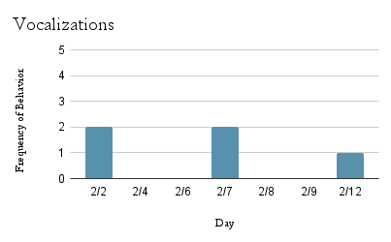 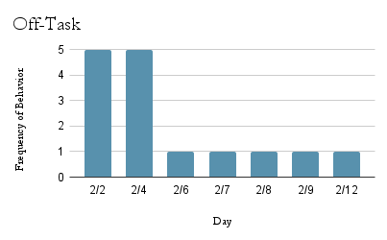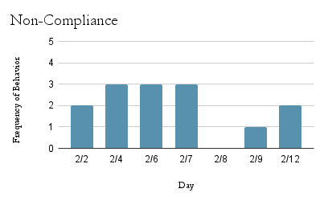 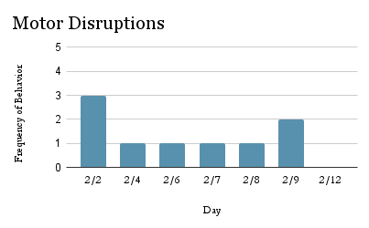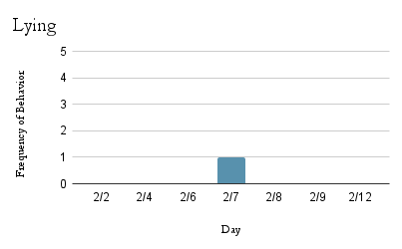

*Baseline:*

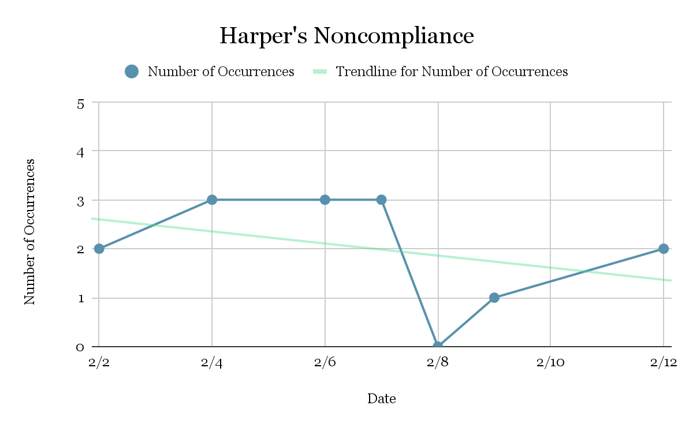

This graph of Hannah’s baseline behaviors focuses on her noncompliance behaviors between 2/2/2024 and 2/12/2024. The data ranges from zero to three instances per day over the course of ten days, with seven points of data. Hannah’s median number of noncompliance is two instances.

PROBLEM ANALYSIS / HYPOTHESIS TESTING

Multiple data sources and assessment methods lend themselves to the conceptualization of Hannah’s behavioral functioning. Various assessments, observations, and data have shown that there are prevalent issues with noncompliance, vocalizations, being off-task, motor disruptions, and dishonesty. Namely, noncompliance is the most prevalent behavior and it impacts the classroom environment, her academic performance, and social interactions. Hannah is very academically capable and has the skills to complete the tasks asked of her. Considering interviews, parent and teacher forms, and observation data, Hannah’s main setting events include academics and lack of a respectful teacher relationship. Identified antecedents include Hannah being told to start something, and being told to stop doing a preferred activity or put away a preferred item. The target behavior has been defined as Hannah refusing to complete a task asked of her, or her saying “No” to an authority figure. Consequences that have been noted are the teacher taking away her preferred item, her teacher stopping her preferred activity, the teacher disciplining her in front of her peers, and her teacher arguing with Hannah. The functions of Hannah’s behavior are hypothesized to be task avoidance and access to preferred items/activities.

*Competing Pathways*

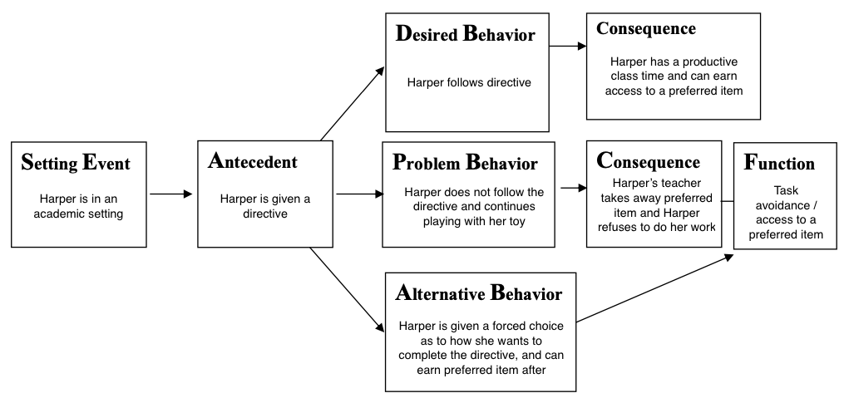

The above is a Competing Pathway specific to one of Hannah’s common behaviors. A "competing pathway" refers to a concept in behavioral analysis, particularly within Positive Behavioral Support (PBS), where it represents a visual tool that helps identify and analyze alternative, desired behaviors that can effectively replace a problematic behavior. This essentially provides a "competing" option to the undesirable action by addressing the same underlying function or purpose that maintains the problem behavior. It also allows for the development of targeted interventions based on the identified function of the behavior. This pathway is one example of alternative ways to view and work with Hannah’s behaviors.

CONCLUSION

*Summary*

Hannah’s main behaviors of focus are noncompliance, dishonesty, vocalizations, motor disruption, and off-task behavior. Most frequently, noncompliance. Information was gathered from parent and teacher interviews to better understand Hannah’s behaviors in the classroom as well as at home. Both settings seem to be pretty similar, in that Hannah’s noncompliance usually stems from being given a directive, especially when she has a preferred item or is doing a preferred activity. Some of these items and activities include fidget toys, a stuffed animal, and art activities, to name a few. Due to these behaviors, Hannah’s teacher is worried that she will be impacted socially, as she is seeing that some students don’t want to play with Hannah because she gets in trouble. The results of the FBA show that Hannah, on average, shows noncompliance twice a day.

*Preliminary recommendations*

The setting events most common to Hannah’s behaviors include being in an academic setting and not having a strong or respectful relationship between student and teacher/aide. Based on these setting events, it is recommended that the following strategies be implemented:

* Create a bond out of mutual respect between the student and teacher/aide
* Create a positive learning environment for Hannah, that includes items that are motivating for her
* Utilize a classroom reward system that focuses on the positive behaviors all students perform as a secondary motivation system for Hannah

The antecedents most common to Hannah’s behaviors include Hannah being told to start something, and being told to stop doing a preferred activity or put away a preferred item. Based on these antecedents, it is recommended that the following strategies be implemented:

* Giving Hannah a choice between two tasks that need to be completed, but it’s her decision in what order they need to completed
* Providing a structured schedule with expectations for each section of the day
* Priming Hannah and reminding her what the next task of the day is and what the expectations and goals are for that task
* Implementing a high-probability sequence: present a series of tasks that Hannah is likely to comply with before a more challenging task
* Behavior momentum: present a series of easier tasks before a more difficult task

When Hannah is faced with these setting events and antecedents, she will often be noncompliant. Some replacement behavior strategies that can be implemented with Hannah include:

* Asking for a break instead of leaving the room when frustrated
* Raising her hand to speak in class instead of yelling out
* Requesting help from a peer instead of giving up on a task
* Using calming breathing techniques instead of lashing out
* Asking for a preferred activity when feeling overwhelmed

If Hannah continues to display this behavior still, it is important to establish consistent consequence strategies to best respond to and minimize the behaviors. These strategies include:

* Using a calm, neutral voice to remind Hannah of the expectations and when they are not being met
* Approach Hannah in a calm manner and ensure mutual respect and kindness
* Give Hannah a choice of how to calm her body, such as a walk, taking a sensory break, drinking water, or taking deep breaths
* Allow Hannah time to self-regulate and regroup when she’s ready
* Remind Hannah that she is in control of how she reacts to situations, and what she can do in the present moment
* Remain neutral in events that appear to be attention-seeking so long as Hannah is not a threat to herself or others’ safety

In the event that Hannah escalates and becomes a danger to herself or others, either Hannah should be removed from the classroom or the class should be removed from the classroom. Two adults should be with her at all times to ensure her safety. The building principal and school counselor should be notified immediately.

This plan should be monitored on a biweekly basis to ensure that it is going to plan and has fidelity. The case manager will check in with the teacher and aide to ensure that the correct steps are being taken to minimize Hannah’s behaviors. This plan should be evaluated on a monthly basis to determine its effectiveness in minimizing the behaviors of concern. If over a three month period there is no positive impact, the plan should be revised to best suit the situation and needs of all involved. If the behaviors come to 0% over a three month period, then the plan should be stopped and the case manager will continue to check in and informally monitor the students’ behaviors, should another need arise.

*Behavior Intervention Plan*

ACADEMIC AND LIFESTYLE CONTENT

Hannah is a first grade student in a general education classroom at Old Farmers Road School. Hannah lives at home with her mother, father, and brother, Simon. Hannah has two dogs who she enjoys playing with. Hannah enjoys karate, art, and playing video games. Hannah’s favorite subject in school is Science, and her least favorite subject in school is Language Arts.

Hannah does have some sensory differences and does not enjoy the feeling of restrictive clothing or footwear. For this reason, Hannah will typically come into school in a big tshirt/dress and Crocs, regardless of weather. There have been conflicts having to do with recess and gym attire given her clothing choices. The importance of appropriate clothing for health and safety have been addressed with Hannah, but she refuses to wear any other kind of attire.

Besides sensory differences, Hannah’s main areas of concern are defiance and dishonesty. Oftentimes, Hannah will become defiant when faced with a task that would interrupt a preferred activity or a task that was undesirable to her. Hannah will be dishonest in times where it benefits her, such as if she is asked if she did something wrong, and would get in trouble for it; or if it would take a preferred item away from her (ex. “Hannah, do you have something in your hands right now?” “No.”). Once Hannah displays these behaviors and is confronted about them, she typically will become frustrated, raise her voice, and shut down. Once Hannah is in this state, it is difficult to get her back to calm and ready to learn. These behaviors are reported to be seen at home as well as in school.

PROBLEM BEHAVIOR

Hannah’s target behavior is noncompliance. Hannah’s noncompliance normally looks like: saying no, physically refusing to complete a task, shaking her head “no,” and choosing to do an alternative task aside from the one being asked of her. Non-examples of this behavior include responding “No” as part of a normal conversation response, not completing a task because she did not hear the instruction, or if she was distracted and completed an alternate task instead of the one asked of her.

PROBLEM ROUTINES

Hannah’s main identified setting events include academics and lack of a respectful teacher relationship. Identified antecedents include Hannah being told to start something, and being told to stop doing a preferred activity or put away a preferred item. The target behavior has been defined as Hannah refusing to complete a task asked of her, or her saying “No” to an authority figure. Consequences that have been noted are the teacher taking away her preferred item, her teacher stopping her preferred activity, the teacher verbally disciplining her in front of her peers, and her teacher arguing with Hannah.

FUNCTIONAL ASSESSMENT HYPOTHESES

Given the identified setting events, antecedents, problem behavior, and consequences, it is hypothesized that the functions of Hannah’s behavior are task avoidance and access to preferred items/activities.

INTERVENTION

*Foundation*

In her current classroom setting, Mrs. Hayes and the classroom aide use the following interventions to address Hannah’s behaviors: Flexible seating (Hannah seems indifferent to this, there have been no academic changes since beginning to use it in September); being a “teacher’s helper” (When Hannah is being respectful, she is given this role to get up and move around the classroom); using fidget tools (Hannah has used these more as toys); extra time to complete assignments as needed; and positive statements (Ms. Hayes gives Hannah positive praise at some points throughout the day). Despite these efforts, Hannah’s behaviors continue to be a concern for Mrs. Hayes.

*Prevention*

The hypothesized antecedents to Hannah’s noncompliance include being told to start something, being told to stop doing a preferred activity, or being told to put away a preferred item. In order to prevent the behaviors from happening, Hannah’s teacher will do as follows: (1) keep routines as consistent as possible for Hannah so transitions from one activity to the next are smoother; (2) give Hannah a heads up about any differences in their normal routine/schedule so she can anticipate the change ahead of time; (3) give Hannah a two minute “heads up” when a preferred activity will be ending so as to ensure a smooth transition; (4) reinforce Hannah’s positive behaviors (such as compliance) with verbal praise or a high five/fist bump; (5) allow Hannah to earn designated preferred item/activity time after a predetermined number of completed activities (ex. First, complete the math worksheet, then you can have 5 minutes of time to have your fidget at your desk); and (6) speak to Hannah with a calm voice and refrain from arguing with her, in public or in private.

*Teaching*

In order to help Hannah with becoming more compliant, teaching her some strategies may go a long way. It would be beneficial for Hannah if her teacher explained the daily routine with her, and paired it with her expectation of each area of the routine (ex. “During math time, we will use a quiet voice and finish our work” or “During indoor recess, you may play with your toys but need to keep a quiet voice”). By setting these expectations and allowing Hannah to fully understand the daily routine, she will be fully prepared for what is to come during her time at school. Another teaching strategy is discussing with Hannah alternatives to shutting down when she doesn’t want to do something. Examples of this include: asking for one more minute to wrap up what she’s doing, deep breaths, and asking when the next time she’ll have access to the preferred item/activity will be (so as to give her something to look forward to/work towards). These strategies may need to be given as a reminder after the initial teaching if Hannah does not fully understand them the first time.

*Consequences*

When Hannah displays noncompliance, the following consequences should be set into place. Reductive consequences, or consequences that would render Hannah’s noncompliance ineffective, include removing access to her preferred task/item until the teacher’s instructions are followed (ex. “Once you write your paragraph, then you will be able to use your fidget again.”). Instructional consequences, or consequences that make Hannah’s compliance more effective, include immediately providing Hannah with positive praise and access to her preferred item/activity when she complies. By using this strategy consistently, Hannah will learn that noncompliance will result in a loss of access to her preferred task or activity, and compliance will result in immediate praise and access to her preferred task or activity. An additional instructional consequence that would reinforce Hannah’s compliance includes a positive letter home to her parents at the end of the day, so that her good behavior can be communicated to and celebrated with her family at home.

Should Hannah’s behavior ever escalate to the point where she is a danger to herself or others, the following crisis plan should be followed. First, the teacher should ask Hannah what is upsetting her. If Hannah is unable to communicate her feelings and needs and continues to be a danger to herself or others, her class should be removed to the pod/hallway area outside of her classroom. The vice principal and school counselor should be called immediately, and upon their arrival the classroom teacher should remove the other students and continue their learning in the hallway. The school counselor and vice principal will then try to de-escalate Hannah. If the classroom environment is affecting her ability to calm down, she will be brought to the sensory room to best control her actions. At this point, the class may return to their classroom. When Hannah returns to a calm, safe state, she can be slowly reintroduced to the classroom. Documentation of these events (time, duration, ABC’s, etc.) should be recorded and stored for future reference. The classroom teacher will converse with the school counselor and vice principal to discuss the situation and how to best prevent future occurrences. The school officials will send an email home to the parents to notify them of what occurred on the same day of the instance.

*Goal Setting*

The goal is for Hannah to be compliant in the classroom and follow her teachers’ directions. Ideally, Hannah’s noncompliance will reduce to zero instances by the end of the school year, but her short term goal is to reduce to one instance of noncompliance each day in a two week time frame, by 3/5/2025.

PROGRESS MONITORING AND EVALUATION

*Data Collection and Procedures*

Observations were conducted to collect baseline data on Hannah’s behavior from 2/2/2024 to 2/12/2024. Following the development of the intervention plan, the plan was put into place between 2/21/2023 and 2/28/2023. During the intervention period, frequency data was collected to evaluate the potential impact of the interventions put into place. All observations were taken in Mrs. Hayes’ classroom throughout the day. Whenever Hannah exhibited noncompliance, the classroom aide would discreetly record the data on a sheet of paper.

*Data Display*

*Figure 1: Table 1: Hannah’s Noncompliance Baseline and Intervention Data*

| *Baseline* | |
| --- | --- |
| *Date* | *Number of Occurrences* |
| 2/2/2024 | 2 |
| 2/4/2024 | 3 |
| 2/6/2024 | 3 |
| 2/7/2024 | 3 |
| 2/8/2024 | 0 |
| 2/9/2024 | 1 |
| 2/12/2024 | 2 |
| *Intervention* | |
| *Date* | *Number of Occurrences* |
| 2/20/2024 | 3 |
| 2/21/2024 | 3 |
| 2/22/2024 | 1 |
| 2/23/2024 | 2 |
| 2/25/2024 | 1 |
| 2/27/2024 | 3 |
| 2/28/2024 | 1 |

*Figure 2: Chart 1: Hannah’s Noncompliance Baseline and Intervention Data*

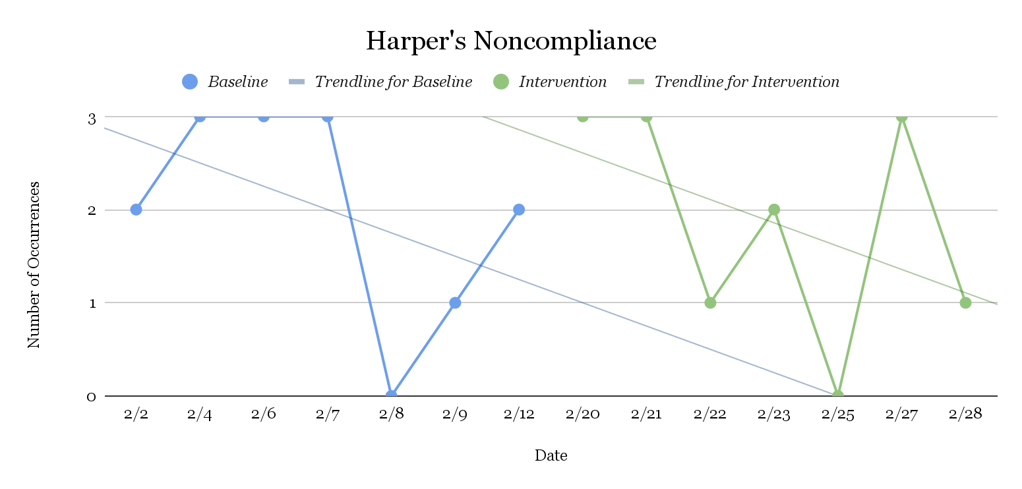

*Interpretation* *of Data*

Hannah’s data in the above graph and table show that she was originally exhibiting an average of 2.0 instances of noncompliance during the baseline period, before intervention was implemented. The data ranged from 0 to 3 instances of noncompliant behavior. The initial overall trend of behavior for the baseline period was in a downward trend. Hannah’s data during the intervention period was, on an average, 1.9 instances of noncompliance, after the intervention was implemented. This data ranged from 0 to 3 instances of noncompliant behavior, same as the baseline data. It should be noted that though the highest amount of noncompliant behaviors (3 instances) occurred on the first day of implementation, as well as the first Monday after implementation. Additionally, Hannah’s noncompliance gradually decreased through the week. This may suggest that Hannah will take a while to adjust to the intervention, but it did positively affect her behavior in terms of instances of noncompliance. Overall, there was a downward trend during the intervention period as well.

*Timelines for Data Collection/Review and Decision Rules*

This intervention was implemented on Tuesday, February 20th, 2025. This intervention proves to reduce her behaviors slightly, though it is expected to more greatly reduce her behaviors as she becomes more accustomed to it. It is recommended that this intervention should be continued and reassessed for effectiveness in two week’s time, on 3/5/2025. During this time, frequency data should continue to be recorded and graphed weekly. If at the end of this two week period it is determined that Hannah’s behavior has not improved in any way, then alternative interventions may be considered. All members of Hannah’s team including her parents, teachers, School Counselor, and School Psychologist should be present at an articulation to discuss these findings and find an alternative intervention to continue this course of action so as to keep everyone in the loop and to foster a strong home to school connection.

CONTEXTUAL FIT

The interventions and data collection outlined above have been functional and not problematic for Mrs. Hayes and the classroom aide to implement and record. Mrs. Hayes reported 95% treatment integrity, as there were days that some unexpected changes needed to be made to the first grade schedule that she could not prepare Hannah for at the beginning of the day as planned, but she did give her as early a heads up as possible during the day as she became aware of it. The plan was followed, however, as intended for the vast majority of this process, and integrity data met usual standards. OVerall, Mrs. Hayes felt that these suggested interventions were worthwhile, and she would like to continue to develop these skills of focus with Hannah.

POSITIVE IMPACT

In the beginning of the year, Hannah had instances of noncompliance that averaged to about 2.0 instances per day. After implementing the intervention for seven days, the average number of instances per day was 1.8. This reduction resulted in an effect size of 0.059, which is considered small. As said earlier, it may be too soon to see the true effect of this intervention of Hannah’s behavior due to the novelty of it. Interventions should be continued as intended and modifications should be made as needed. Further progress data should be recorded and taken into consideration every two weeks to determine the continued effectiveness of the intervention as time goes on.